FV MISCONDUCT REPORT
This form is to be used as the recording document following the issue of a red card. It is to be emailed within 48 hours of the incident. Please ensure you save a copy for your reference. Please email to the Discipline department at
discipline@footballvictoria.com.au

League: |  | Match:
Grade: |  | Played At:
Date: |  | Name of Club:
FFA ID: |  | Shirt Number:
Player Name:
Please tick or BOLD the applicable offence indicating why the Red Card was issued.
€ R1 - Denial of a clear goal scoring opportunity by deliberately handling the ball
€ R2 - Denial of a clear goal scoring opportunity by an offence punishable by a free kick
€ R3 - Serious foul play
€ R4 - Spitting
€ R5 - Violent conduct
€ R6 - Uses offensive, insulting or abusive language and/or gestures
€ R7 - Second caution in the same match
€ R8 - Offences against Match Officials
What Happened? (Please use wording from the GDT, quote and use exact language where applicable)

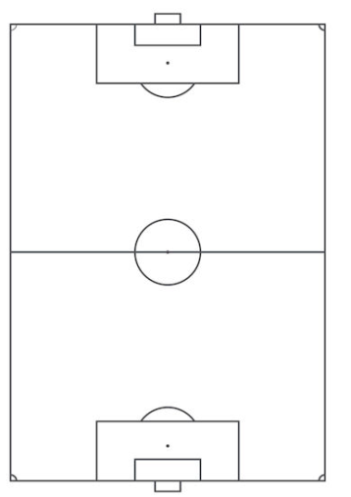

Please fill out the following:

X=incident
O=Ball
R=Referee
- The incident occurred in the ____ minute
- Incident from the ball: ____ metres
- Referee from the incident: ____ metres

Was anybody injured? Yes /No

If yes, Please specify:

Were there any problems after the red card was shown? Yes/No
If yes, please fill out a separate incident report

Referee Name:

